For Immediate Publication / Broadcast / Telecast
PR/1456

IDBI Bank launches Retail Loan Utsav across 310 branches

To celebrate the upcoming festive season, IDBI Bank is launching a special ‘Retail Loan Utsav’ from September 22 to October 4, 2025. Extending the Bank’s brand philosophy of ‘Bank Aisa Dost Jaisa’, the initiative highlights the Bank’s customer-centric approach with exclusive offerings across a wide spectrum of retail loans including Housing Loan, Auto Loan, Education Loan, Loan Against Property and Personal Loan.
The ‘Retail Loan Utsav’ is designed to resonate with the evolving aspirations of Indian households as they make important lifestyle and financial decisions during this auspicious festive period.
The Bank has identified 310 select branches to champion the ‘Retail Loan Utsav’ that will cover 156 districts across 29 states in India.
Shri Sumit Phakka, DMD, IDBI Bank stated, “The Retail Loan Utsav is a key initiative to strengthen our engagement with customers during the festive season. By offering customized loan features, attractive terms, and seamless processing, we aim to provide a truly rewarding and delightful experience for our customers as they celebrate new beginnings.”

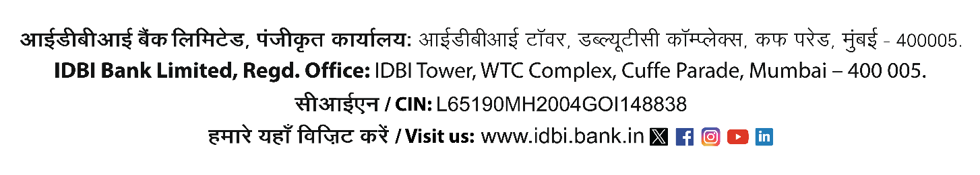
All representatives of Print, Wire and Electronic Media.

